# How to Perform SWV scan on Pico using a computer

## For Pico, we use FTDT module to talk to the Pico from a computer.

Connect the TX and RX pins on Pico to the RXD and TXD pins on the FTDI. Connect the 5V pin on Pico to the VBUS pin, GND to GND. Like in the following figure.

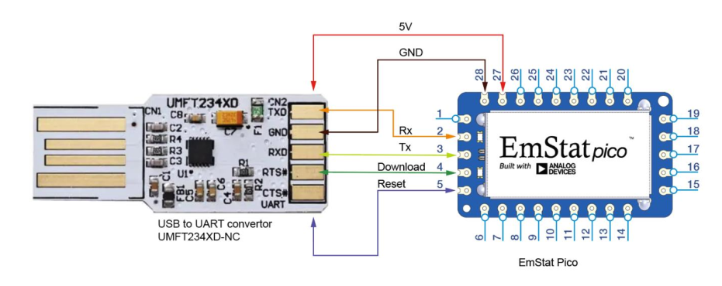

Plug the FTDI module to USB port on computer.

I have provided a python library to talk to Pico and Parse the results.

You can install the necessary packages with PyPI, then run the script with

python picoTest.py.

I have connected the WE0, CE0+RE0 to a 100kohm resistor, the output will be a plot like this:

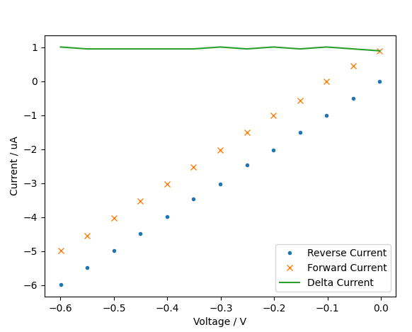

If you need more help on how the pico works, I have attached a few documents for you:

1. Pico board.pdf : some schematics from Analog Devices, but this is not the schematics of Pico itself.
2. Pico method script.pdf, pico comm protocol.pdf: describes how to use method script to communicate with pico